
डॉ. ए.पी.जे. अब्दुल कलाम तकनीकी विश्वविद्यालय, लखनऊ
Dr. A.P.J. Abdul Kalam Technical University, Lucknow

Examination Attendance System
परीक्षा उपस्थिति प्रणाली

User Manual & Feature Guide

Version 2.0 · Phase 2

Developed by
Technotouch Solutions Pvt Ltd
for
Dr. A.P.J. Abdul Kalam Technical University, Lucknow

Contents
1. About the System
2. Roles & Access
3. Getting Started
4. Feature Overview
5. Centres Management
6. Exam Sessions & Timetable
7. Candidates & Admit Cards
8. Rooms & Seating Plan
9. Invigilator Roster
10. QR Attendance & Capture
11. AI Co-Pilot
12. Live Monitor
13. Reconciliation & Sign-off
14. Reports & Exports
15. Incidents & Unfair Means (UFM)
16. Evacuation Planning
17. AKTU Portal Integration
18. Offline Mode & PWA Installation
19. Troubleshooting
20. Support & Credits

1. About the System
The AKTU Examination Attendance System is a secure, bilingual (English/Hindi) web application that digitises every step of running an examination centre — from candidate onboarding and seating plans to real-time QR-based attendance, AI-assisted verification, incident logging, reconciliation, and official reporting.
Key highlights:
- Bilingual UI (English + हिन्दी) throughout every screen.
- Progressive Web App (PWA) — installs to phone/tablet and works offline.
- QR-code based candidate attendance with camera capture and audio feedback.
- AI-powered timetable import, room-scan analysis, face match and UFM assistance.
- Role-based access control (Super Admin, Superintendent, Invigilator, Auditor).
- One-click Excel / PDF / photo exports meeting AKTU reporting formats.
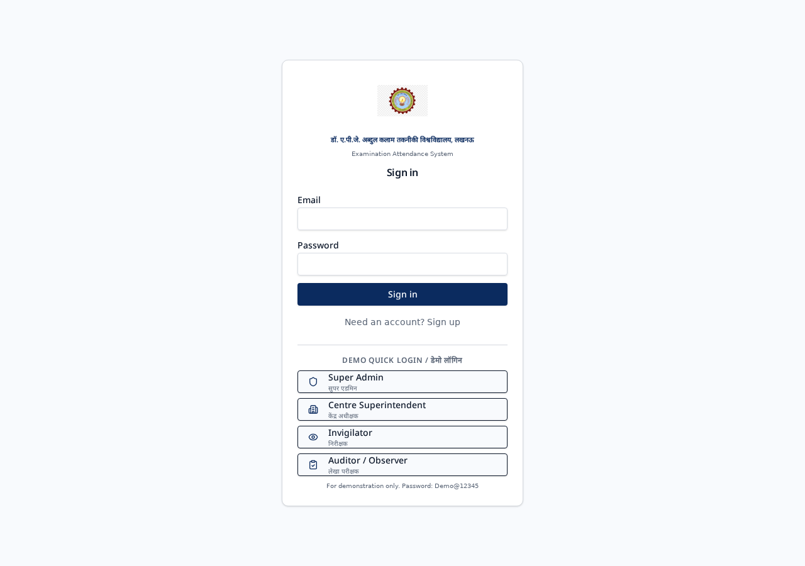
Figure: The AKTU-branded secure login screen (English + Hindi).

2. Roles & Access
The system enforces four distinct roles. Each user only sees the features permitted by their role.
Role | Responsibilities
Super Admin / सुपर एडमिन | Full control — manages centres, colleges, users, global settings, AKTU portal.
Centre Superintendent / केंद्र अधीक्षक | Manages a specific centre: sessions, rooms, seating, roster, reconciliation, reports.
Invigilator / निरीक्षक | Marks attendance, scans QR codes, captures candidate photos, raises incidents.
Auditor / Observer / लेखा परीक्षक | Read-only access — live monitoring, reports, and audit logs.

3. Getting Started

3.1 Signing In
- Open the application URL in Chrome, Edge or Safari.
- Enter your official e-mail and password on the login screen.
- First-time users are automatically taken to Change Password.
- Demo accounts (Super Admin, Superintendent, Invigilator, Auditor) are available on the login screen with the password Demo@12345 for training.

3.2 Installing as an App (PWA)
- On mobile Chrome/Safari, tap the browser menu → ‘Add to Home Screen’.
- On desktop, click the install icon in the address bar when prompted.
- Once installed, the app opens in its own window and works even without internet.
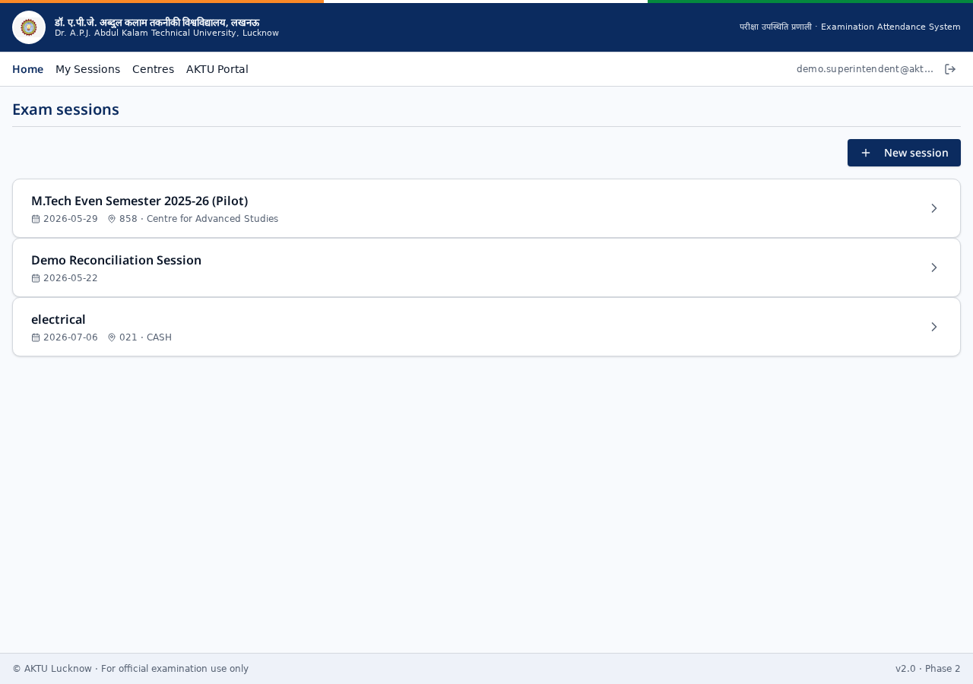
Figure: Home / My Sessions screen after signing in.

4. Feature Overview
The complete feature list is grouped below. Each is detailed in the following chapters.
Module | Description
Centres | Create and manage multiple examination centres, users and centre-level settings.
Exam Sessions | Schedule morning/afternoon sittings, define subjects, upload timetables (AI-assisted).
Candidates | Bulk import candidates, view and edit records, link photos and colleges.
Admit Cards | Generate branded AKTU admit-card PDFs with QR codes for every candidate.
Rooms | Configure rooms, capacity, layout; interactive 3D Room Twin visualiser.
Seating Plan | Automated seating allocation with printable seating chart & door-notice PDFs.
Invigilator Roster | Assign invigilators to rooms and sessions with duty sheets.
QR Attendance | Scan candidate QR / roll number; live camera capture and audio feedback.
AI Co-Pilot | In-app AI helper: session import, image analysis, face match, UFM drafting.
Live Monitor | Real-time centre dashboard: rooms, present/absent counts, incidents.
Reconciliation | End-of-session sign-off between invigilators and superintendent.
Reports & Exports | Excel / PDF / photo-pack exports in AKTU reporting formats.
Incidents | Log and track any centre incident with photographic evidence.
UFM (Unfair Means) | Structured Unfair-Means case management with AI-drafted statements.
Evacuation | Emergency evacuation plan and drill records per centre.
AKTU Portal | Direct links to official AKTU examination and result services.
Bilingual UI | Every screen in English + हिन्दी — no separate language switch needed.
Offline Mode | Attendance queued locally when offline, auto-syncs when back online.

5. Centres Management
Add centres, edit codes, city, capacity and users. Superintendents access only their assigned centres.
- Create / edit / archive centres.
- Manage centre-level users and their roles.
- Configure centre settings (working hours, contact, branding).
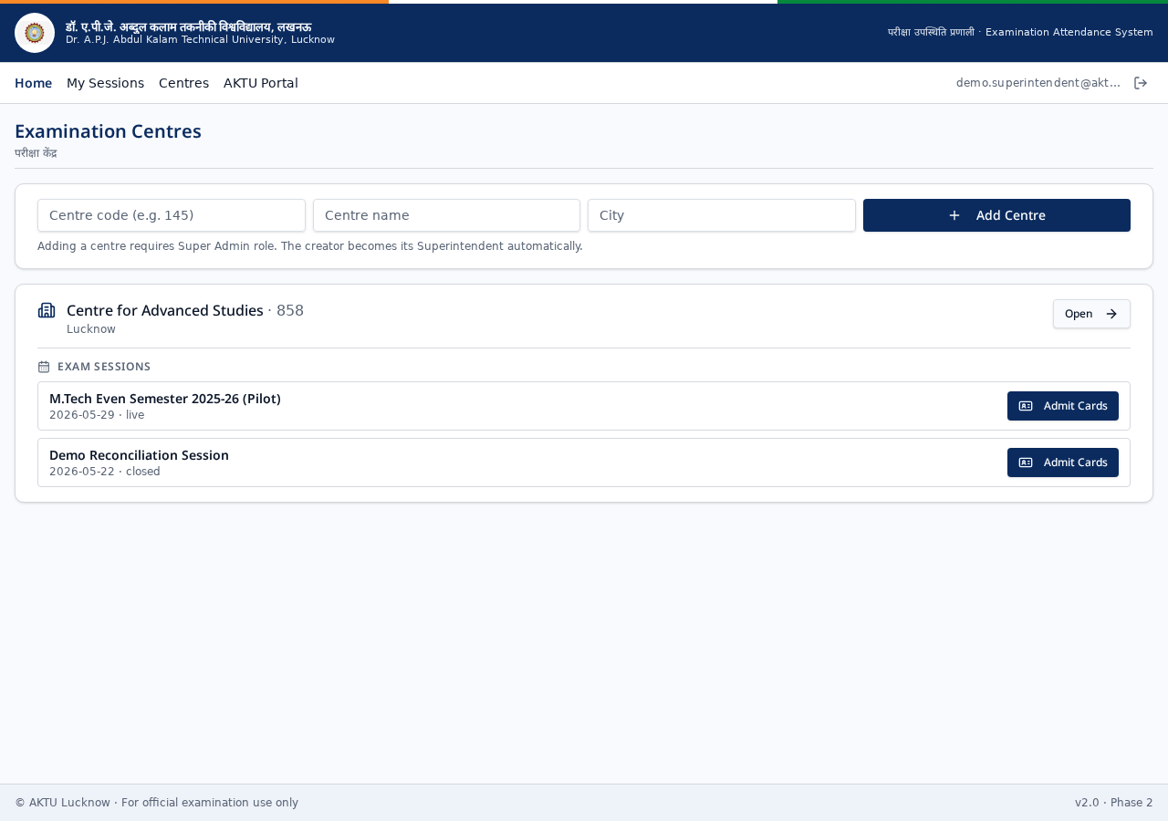
Figure: Centres directory listing all examination centres.

6. Exam Sessions & Timetable
Sessions represent one sitting of an exam (date + shift + paper). Timetables can be imported from a PDF or image using AI.
- Create sessions with date, shift and subject.
- AI Session Import: upload the AKTU timetable and it is parsed automatically.
- Timetable view with day-wise reports.
- Publish / go-live control per session.

Figure: Exam Sessions list for a centre.

7. Candidates & Admit Cards
Manage the full candidate roster and issue branded admit cards.
- Bulk import candidates via CSV or AI extraction from PDF.
- Individual candidate profile with photo, college and history.
- One-click Admit Card PDF generation with QR code for scanning.
- Attach candidate photos manually or via camera capture.
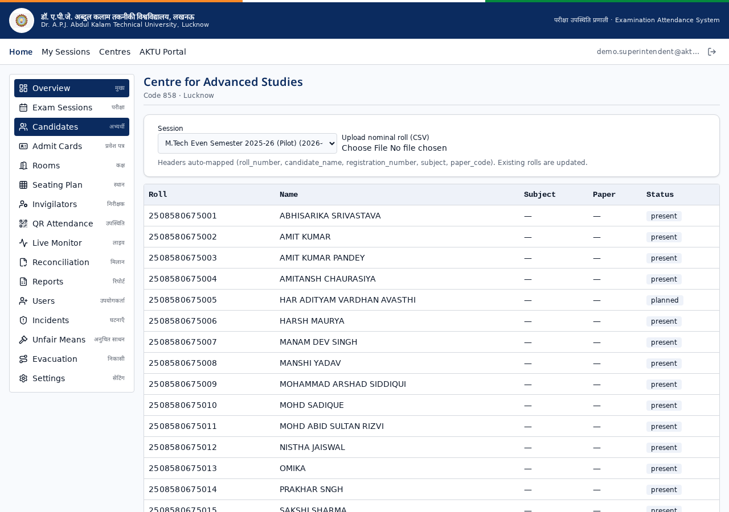
Figure: Candidates list with roll numbers and status.

8. Rooms & Seating Plan
Define rooms, capacity and layout, then generate compliant seating plans.
- Configure rooms with rows × columns and capacity.
- 3D Room Twin: interactive visualisation of the seating layout.
- Automated seating allocation with anti-cheating spacing.
- Seating chart PDF and door-notice PDF for each room.
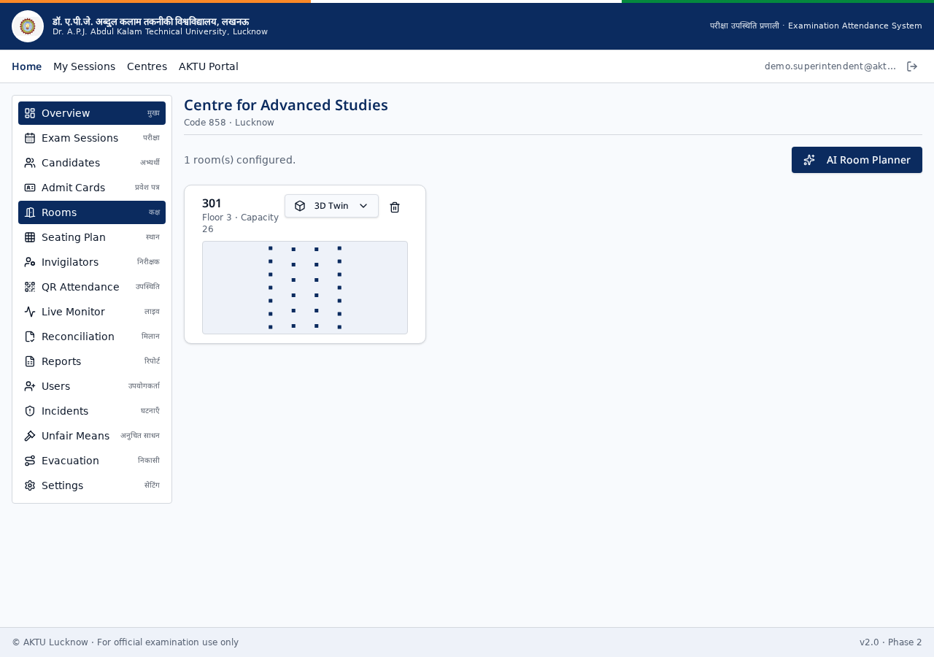
Figure: Room configuration for a centre.

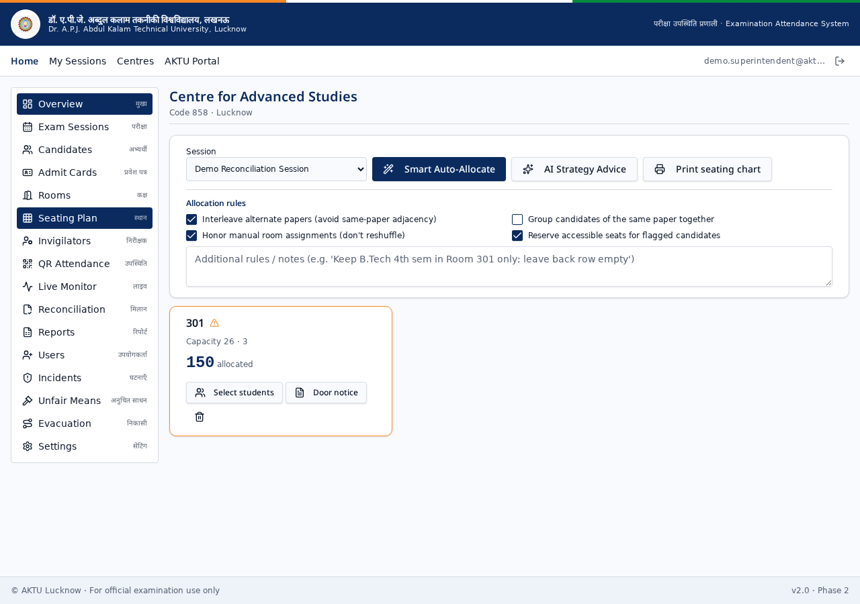
Figure: Seating plan grid view.

9. Invigilator Roster
Assign invigilators to rooms and sessions with printable duty sheets.
- Assign primary and relief invigilators per room.
- Duty conflicts highlighted automatically.
- Roster printable PDF for centre notice board.

10. QR Attendance & Capture
The core invigilator workflow — mark candidates present with a QR scan or roll-number search.
- Live camera QR scanner (works on any modern phone).
- Fallback: search by roll number and mark manually.
- Automatic candidate photo capture with front/rear camera toggle.
- Audio + voice confirmation on each successful scan.
- Duplicate-scan detection (per exam-day, per candidate).
- Offline queue: scans are saved locally when the network drops and sync automatically.
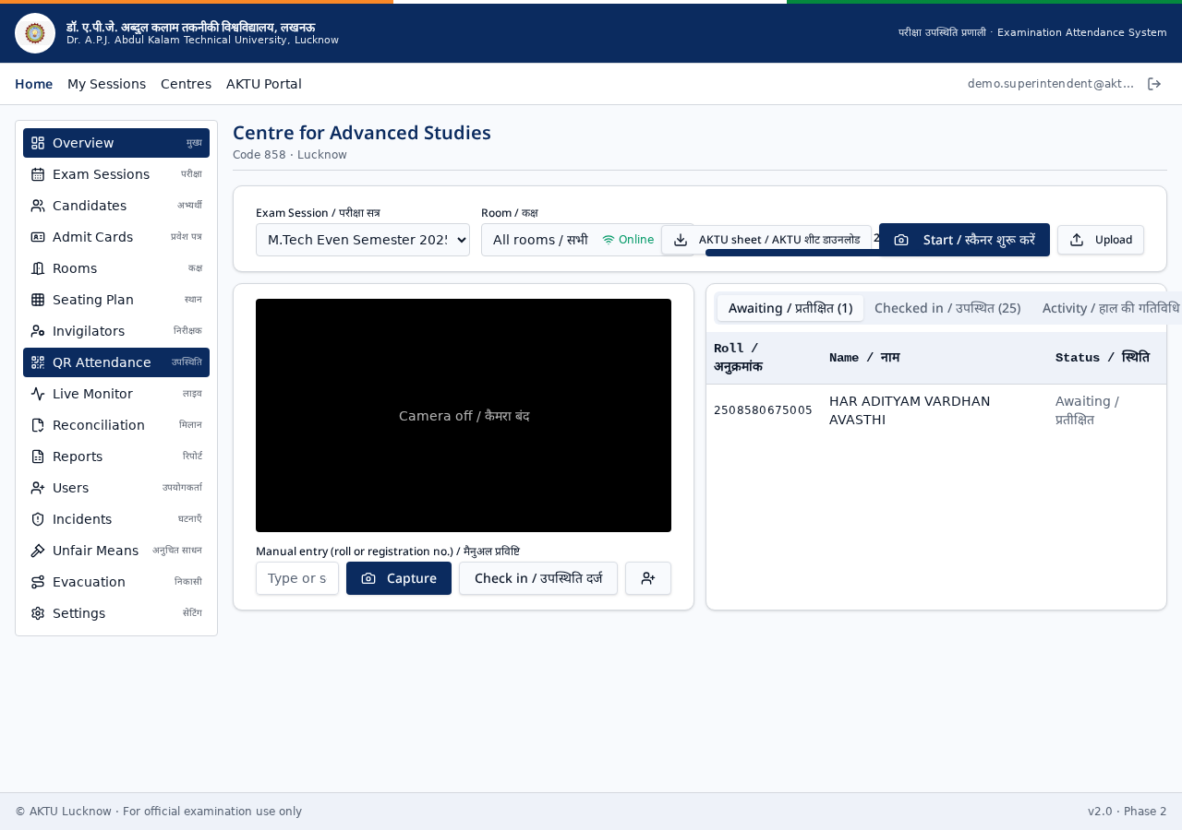
Figure: QR Attendance scan screen.

11. AI Co-Pilot
AI assistance is built directly into the workflow — no extra tools needed.
- AI Session Import: extract timetables from PDFs/images.
- AI Image Analysis: verify candidate photos and admit cards.
- AI Face Match: compare captured photo with admit-card photo.
- AI Room Scan: analyse a photo of the room to detect empty seats / issues.
- AI UFM Assistant: draft unfair-means statements from a description.

12. Live Monitor
Superintendents and auditors see live progress across every room in the centre.
- Room-wise present / absent / awaiting counts.
- Incident and UFM alerts as they happen.
- Auto-refresh — no need to reload the page.
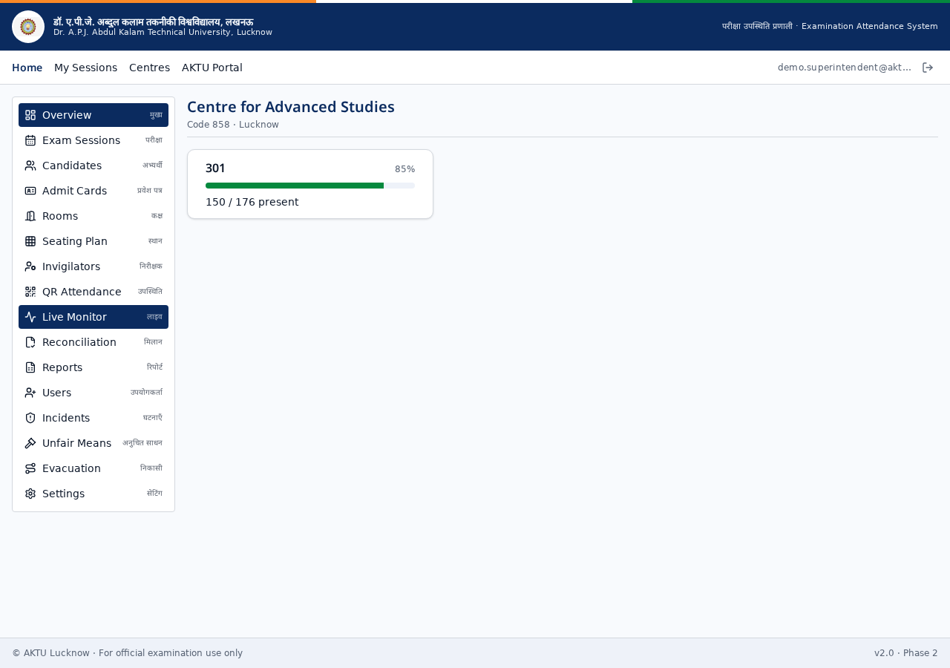
Figure: Real-time centre monitor.

13. Reconciliation & Sign-off
At the end of every session the numbers must reconcile before the paper closes.
- Invigilator submits room totals with digital signature.
- Superintendent counter-signs and locks the session.
- Discrepancies flagged for review before sign-off is allowed.

14. Reports & Exports
One-click generation of every mandated AKTU report.
- Attendance sheet (Excel).
- Official attendance PDF with signatures.
- Candidate photo pack (ZIP) for post-exam verification.
- Session-wise, room-wise and college-wise breakdowns.
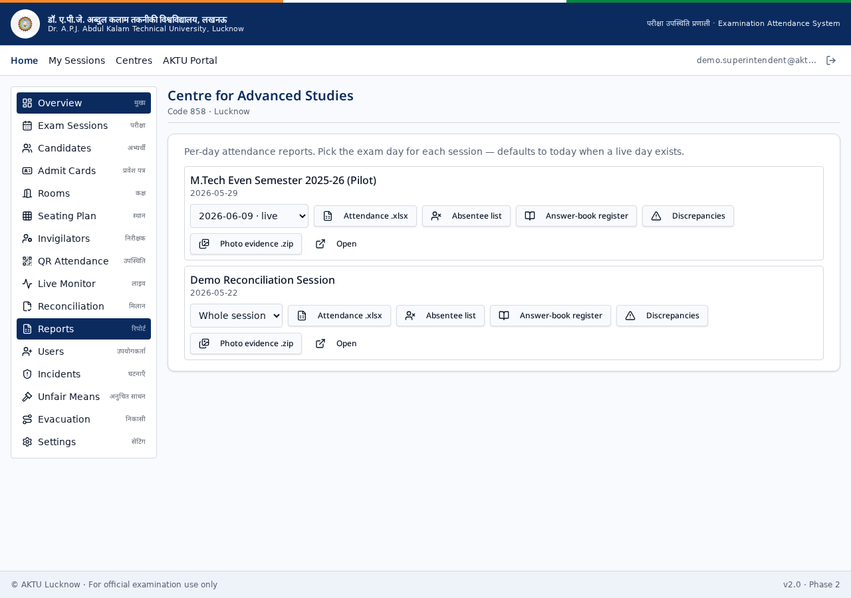
Figure: Reports dashboard with export actions.

15. Incidents & Unfair Means (UFM)
Every out-of-ordinary event is recorded with time-stamp, photo and involved parties.
- Incidents: general disturbances, medical events, equipment failure, etc.
- UFM cases: separate flow with statements, evidence and AI-drafted narrative.
- Audit trail: nothing can be silently deleted.
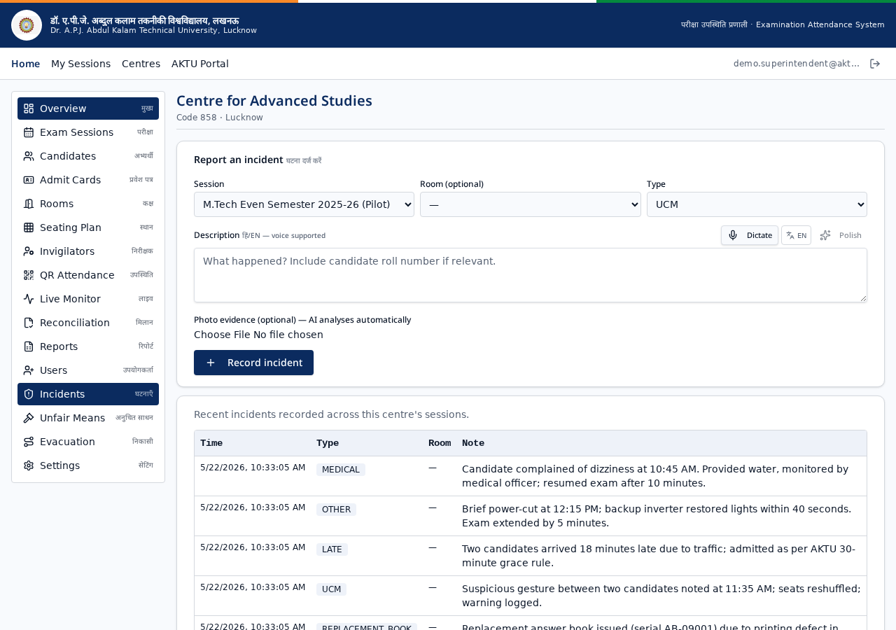
Figure: Incident log for a centre.

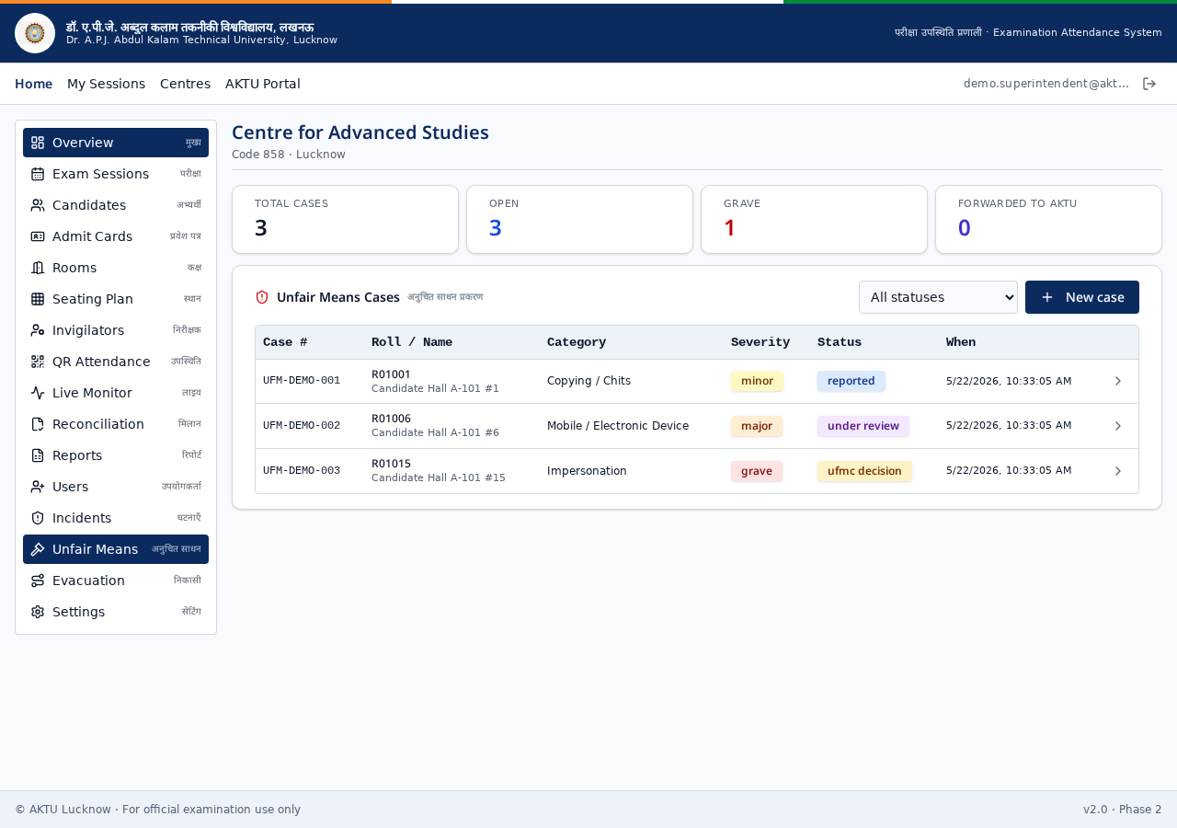
Figure: Unfair Means (UFM) case management screen.

16. Evacuation Planning
Every centre maintains an evacuation plan and drill records.
- Define evacuation routes per building/floor.
- Log evacuation drills with participant counts.
- Emergency contact directory.

17. AKTU Portal Integration
Quick, verified access to the university's official examination and result services.
- Direct links to AKTU examination portal.
- Result services and notices in one place.
- No credential sharing — links open in official AKTU domain.
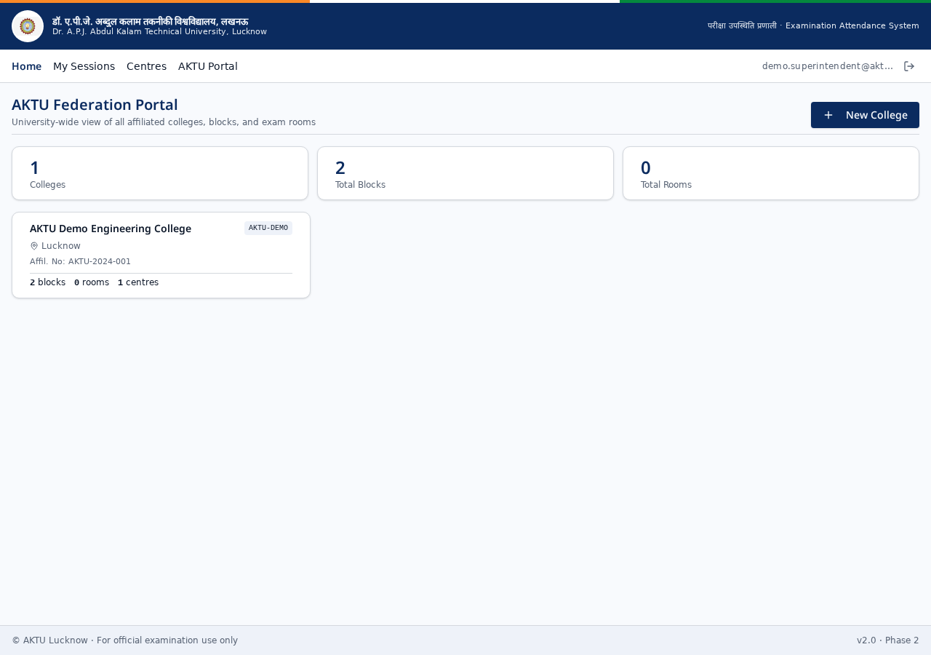
Figure: In-app AKTU portal shortcut screen.

18. Offline Mode & PWA Installation
The app is designed for centres where internet may be patchy.
- Service Worker caches the app shell for offline load.
- Attendance scans queued in browser storage when offline.
- Automatic background sync when the connection returns.
- Install to home-screen from Chrome/Safari — behaves like a native app.

Appendix A — Admit Card Screen
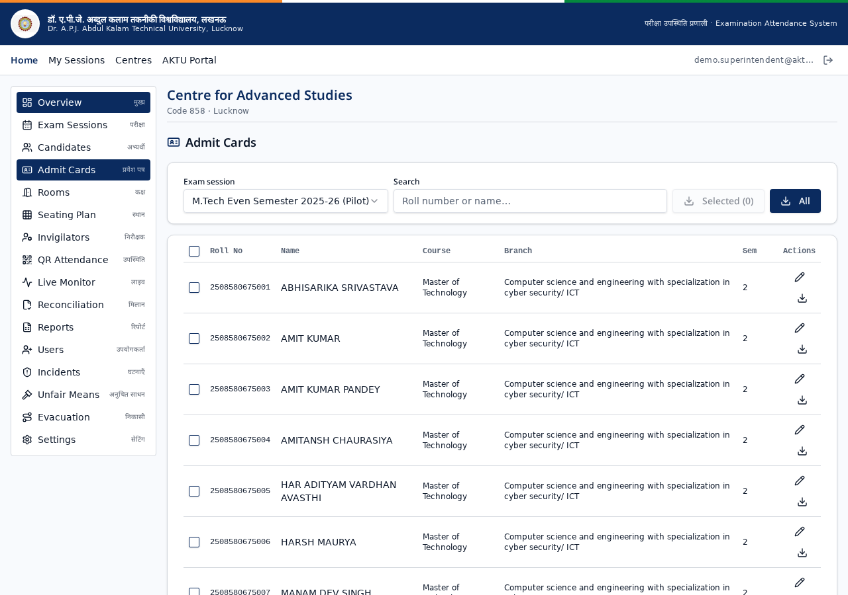
Figure: Admit-card generation and preview.

19. Troubleshooting
Issue | Resolution
Camera does not open | Grant camera permission in the browser address bar and reload the page. On iOS use Safari.
QR scan says ‘already captured for today’ | The candidate is already marked for this exam day. Check the attendance list or contact the superintendent to reset.
Attendance not syncing | Check the offline indicator at the bottom of the screen. Scans will auto-sync once the network is restored.
PDF download blocked | Allow pop-ups / downloads for the site in browser settings.
Forgotten password | Contact your centre superintendent or super admin to trigger a reset.

20. Support & Credits
For technical support, feature requests or on-site training:
- Developer: Technotouch Solutions Pvt Ltd
- Client: Dr. A.P.J. Abdul Kalam Technical University, Lucknow
- Product: AKTU Examination Attendance System (v2.0)

© Technotouch Solutions Pvt Ltd. Developed for AKTU Lucknow. For official examination use only.

